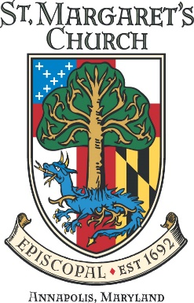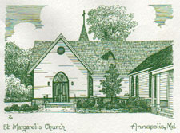

St Margaret’s Episcopal Church Vestry
Subject: Minutes for 20 June 2023
Attending: Kristen Berthelotte (Senior Warden), Katherine Wiernicki (Treasurer), Paul Shurke (Junior Warden), Dave Boyce, Austin Canuel , Matt Chasse, Alden Gross, Mary Holstine, Janice John Z, Chris Prender Z , Susan Roberts, Dan Tootle, Carol Williams, and Jim Barnett (Clerk), Elizabeth Radley (Director of Operations).
Not Attending: Peter Mayer+ (Rector), Patti Sachs+ (Associate Rector), Lana Keelty, Kathy Lang, Ernie Tucker,
Visitors: Gwen Davis and Life Scout Andra Davis.
This meeting was conducted in Hybrid format. Zoom attendees are noted by a “Z” after their name.
1. Opening prayer was given at 7:00 pm by Dave Boyce.
2. The meeting was called to order by the Senior Warden in the absence of the Rector. The May 2023 Vestry minutes were approved.
The Director of Operations indicated that a fire inspection had been completed earlier in the day and the pressure to the fire pumps was not sufficient. The recently hooked up city water does not provide adequate pressure and our booster system is down and needs a part that must be shipped from overseas. We are on “fire watch” until the pressure is restored to the system. Fire watch will require 24/7 manning to guard the campus against any chance of a fire. The lack of a sustained fire watch could have significant negative insurance ramifications. Volunteers were solicited and Austin Canuel stepped up to take the first watch.
A Quorum was noted as present.
Andra Davis presented her proposal for an Eagle Scout project centered on the bee hive area. Specifically, she will construct a fenced enclosure to ensure no one enters. 84 Lumber will provide the materials and the scouts will provide the labor. The work will be done at night so as not to upset the residents in the hives. The work will be done in July and August. The enclosure will be approximately 30X10 feet so there will be plenty of room to move about the hives as necessary.
3. Submitted Reports:
- Treasurers Report (posted):
We continue to run ahead of budget. Good news. A question was asked about clergy compensation and how it could be running behind budget. This was explained as a timing issue with their insurance. Campus rental income is running above projections. The Director of Operations monitors similar venues to ensure we are priced competitively.
- Rector’s Report (posted):
Two Vestry members attended the Annual Father’s Day event on the Broadneck Peninsula. This was well timed to fall between Juneteenth and Father’s Day.
It was noted that there has been a noticeable increase in crime in the county and we will need to review our security precautions in the near term.
- Outreach & Marketing Report (posted):
The report was read pretty much as written.
The Survey remains a work in progress. The Committee is looking for ideas and hopes to have something ready by October 2023.
There was a discussion regarding Realm and its attributes with respect to congregants entering information that might be helpful to the Church.
The Masquerade Ball proceeds are specifically for the Grants subcommittee.
There was a discussion regarding circumventing some business reluctance to give specifically to churches and perhaps we can frame our solicitation around the Grants going out vice the donations coming into the church. Dave Boyce will take a shot at writing a cover letter to that purpose.
- Junior Warden’s Report (posted):
He is researching the potential of moving our sound board from the back of the Sanctuary and free up some additional space. Our current sound board is ancient. It was noted that the speaker system for the organ and sound board are completely separate so any investment in a new sound board would necessarily include a speaker system. The Junior Warden was suggesting that this be added to the major capital investment plan for the future.
- Senior Wardens Report (posted):
The Senior Warden is looking for a volunteer to coordinate and run the Wine and Gift Card basket event for the Masquerade Extravaganza later in the fall.
The idea of a 50/50 type raffle was proffered.

5. For the Good of the Order.
There may be an opportunity to conduct a “Honey and Harvest” event on campus in 2024. We should have the requisite volume for such an event.
Thanks to Alden and the junior Warden for setting up the Zoom equipment,
The meeting was adjourned at 8:33 PM.

