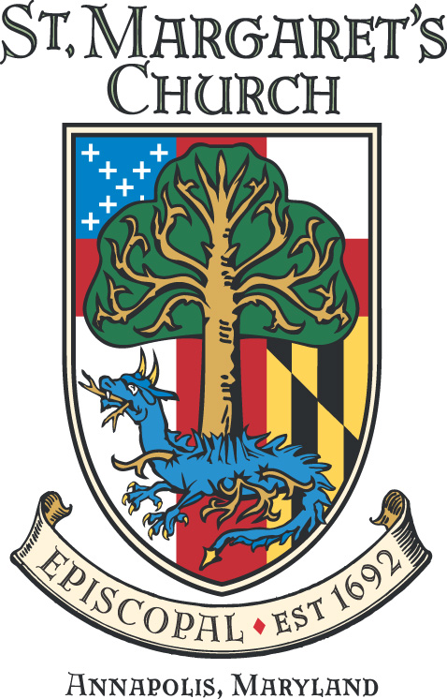
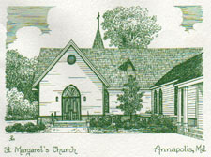
St. Margaret’s Church
Westminster Parish
Annual Meeting
Sunday, January 23, 2022

!. The Rector opened the Annual Meeting for 2022 with a prayer at 1:01 PM. Because of the ongoing pandemic, the 2022 Annual Meeting was conducted over Zoom.

2. Assumption of Secretary: Jim Barnett, as the Clerk, assumed the secretarial duties for the 2022 Annual Meeting.

3. Approval of the Minutes from January 24, 2021. Motion to approve – Noted in the affirmative without exception.

4. The Rector presented a slide show of the year in review.

5. Election of New Vestry Members: The Rector noted that there were 4 candidates for Vestry this year to fill 4 open positions. The candidates are Matt Chasse, Janice Johns, Ernie Tucker, and Dan Tootle. In addition, there is one candidate for Youth Vestry Member, Austin Canuel. The Rector asked the congregants if there were any additional candidates for Vestry. Seeing none he proceeded with the vote.
Motion to approve – Voted by acclimation and noted in the affirmative without exception.

5. The Rector’s Report: A Power point slide show was used to illustrate the report.
The Rector noted progress with live streaming and the challenges it presented for everyone.
He noted that the New Organ was just about here and will greatly benefit everyone.
SMC began the process toward greater racial reconciliation, reconciliation, and reparations. “We are repairing the
breach.”
We have completed the amended bylaws and those will be presented shortly.
We have very recently completed the hook up to city water an no longer need to relay on our old and failing well.
This has been a very difficult year but through the strength of our lay leadership and staff, as well as the congregation, SMC has raised to the challenges.
The Rector then laid out a set of challenges for the coming year.
We will focus on rebuilding our congregation as we move out of the Pandemic.
We will have at least 4 fellowship services each quarter.
We will have a Juneteenth celebration on the 19th of June, and this will be a big service.
We will challenge ourselves to find 30 new pledgers to help bridge the gap in the budget. We need to get closer to our objective of 220 pledgers next year.
We need to balance the budget in 2023.
Finances will continue to be a challenge, but we need to work to both find efficiencies and increase income.
We have allowed for some investment in this budget to advance our formation program. Music will see an increase for both internal programs and external special events.
We need to stay the course as we proceed through the challenges of the Pandemic. We had 160 congregants in the three services this morning and that is very good.
We need to thank our staff and lay officers and particularly the departing Vestry members: Cory Greene, Barbara Friedmann, Luke Morgan and Stacia Bontempo. They have done a fabulous job with half their tenure observed through a Pandemic lens.

6. Senior Warden’s Report: A PowerPoint presentation was used for illustration.
We have made an investment in our Children’s program with the hire of a part time director for this effort.
She reiterated her thanks to the departing Vestry members who have weathered many challenges.
She was appreciative of the efforts of the Organ Committee in delivering a new and very much improved organ.

7. Adoption of the Amended Bylaws: David Allen led this presentation which highlighted the changes from the previous bylaws. The initial draft was provided to Officers and Vestry and many changes and adjustments were made. The Vestry voted to approve the amended version that was then posted to the SMC website for review by all parishioners. Again, several parishioners submitted suggestions, and each was considered and discussed for inclusion.
What did not change, and necessarily had to remain consistent with existing Canon’s, is the definition of membership to the church.
Changes that were needed were then reviewed in turn.
A call for further questions or discussion was made and none were forthcoming.
It was noted that the previous bylaws, and those in place on this day, required “a two-thirds vote of those Voting Members who shall attend any meeting of the members of the Church.” For this reason, attendees on the zoom were asked to vote by show of hands (literally) and a count would be taken.
A Motion was made to accept the amended bylaws: A count was taken, and the requisite two thirds noted in evidence. There were several abstentions noted by the absence of raised hands but greater than two thirds were in the affirmative. The motion carried.

8. Treasurer’s Report: Katherine Wiernicki presented the financials for the year with a slide show.
There was no draw in the Endowment for operations.
The $69,000 that was drawn against the Endowment as a down payment for the Organ will in all likelihood be reimbursed to the Endowment as pledges continue to come in.
We drew $100,000 from the Endowment for the Grants process last year and will do so again this year.
Last year we contributed $20,000 to the Day School scholarship fund to help families impacted by the Pandemic. This commitment will revert to $10,000 in the coming year.
We made investments for our future with the Organ and installation of streaming capabilities. We will continue to look for investment potentials in various areas of our ministry.
We are anticipating an Endowment draw of between 5.2% and 5.7%. It is important to note that the Endowment experienced 2021 growth of $626,000.
In the budget buildout for 2022 the Vestry had to make several very difficult decisions. The budget will be posted on the web site.
It was reminded that after the Building Campaign a few years ago, there was a noticeable drop in pledging as people stepped forward to answer the campaign challenge. This drop was only experienced for one year so it is hoped that we will see pledges raise again during the year following the Organ Campaign.

9. Junior Warden’s Report: The completion of the water hookup to city water should be done shortly.
The HVAC system will soon be repaired.
We are excited about the “Adopt a Bed” project coming up this spring wherein parishioners, families, and groups can take ownership and pride in various campus plots.

10. Music Program Report. Jim Douglas noted the difficulty of conducting an effective music program during the Pandemic.
He noted the new organ and the revitalization of the choir programs as coming soon.
He noted that this is the 24th year for the Third Sunday Band who has had to work through both the Pandemic and several musician changes.

11. Communications Report: We have seen positive impacts with our social media presence.

12. Formation Report: 77 Children are registered for our Children’s formation program. There were 25 at Sunday School today alone.

13.. St. Margaret’s Day School: The Day School continues to see a long waiting list. Tricia Halberg will retire at the end of this school year and move to Florida with her husband Scott.

14. History and Archives Report: The Reconciliation and Reparations history and archives project is on the website. They are looking for additional volunteers to help with their efforts.

15. For the Good of the Order
You all know where we are. Please contact any of us, the Senior Warden, Junior Warden or Vestry to get engaged.

16. With no further business, the Assistant Rector concluded with a prayer and the meeting was adjourned at 2:17 PM.

Faithfully submitted,

Jim Barnett; Clerk and Secretary for the Annual Meeting

